Metal 3D printing optimization with focus on part orientation and support design

**Which modules have been done**

* Component import from STL format (rotation of STL, voxelization of the body, wireframe import)
* Support volume calculation from voxelized body – supported surfaces are all downfacing surfaces
* Part orientation optimization using combination of grid search and gradient descent
* Function for export of optimally oriented part back to STL
* Search of features
  + First method of search based on body volume projection as a opacity into 2D image and search of features in this image – problematic behavior with overlaying features and features which don’t have a gap border – for example chamfer
  + Second search method based on voxelized body and search of point (voxels) which could be clustered into one group (feature). To overcome problem of previous method with distinguishing feature of type chamfer wireframe filtration is integrated, this enables cluster into one feature only point of corresponding feature surface plane.
* Feature cutting
  + For every feature cuts in X and Y direction are made
  + Because of testing multiple types of cut are done (different borders of cuts with respect to height of height of supports, overhang, thin-only for feature width and wider-which captures also feature surroundings, and combination of these...). But from testing experience and for current setup of feature classifying it seems to be most useful cut which captures only thin window of feature boundaries to classify feature class. Second useful is cut which captures whole height of body from bottom surface to top and surroundings of feature
* Feature parameters classification
  + Basic shape – based on dataset of basic body shapes classification using cut section overlay and correlation
  + X, Y size
  + Density of surroundings – that says “how much is feature supported from each side”
  + Height of overhang and height
  + Bottom surface of supports – if it is machine build platform or another part of body itself

**Which modules should be done**

* Create dataset to cover all body parameters with combination with different support structure types and densities
  + Simulate and experimentally check behavior of these combinations
  + Find parameters of body and ranges of these parameters which are more and less important for thermally affected behavior of component
* **Develop and algorithm for support pattern and density prediction** based on feature (or whole body) parameters
  + I think that for beginnings it would be hard enough to focus on very basic body shapes with just one feature, and later move to more complicated bodies which would require multiple supports
* After testing with simulation and experiments switch to any faster and opensource programming language to make algorithm better applicable

**Ideas what could be improved…**

* Maybe don’t be so strict on importing from STL but consider another format which describes features by default. This could make much easier feature classification and move focus to surrounding of feature and feature orientation which could have impact to supports .

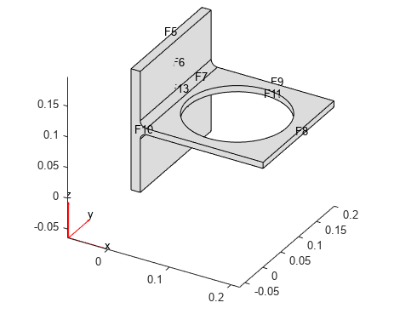

Figure 1 This kind of format which is describing features as default.

* When calculating support volume consider only features which need to be supported – now considering all downfacing surfaces, what is not realistic
* Think about feature cut planes, might be better to cut in feature major and minor plane (instead of X and Y. This could improve behavior for bodies and features which are not perpendicular acc to coordinate system of STL file